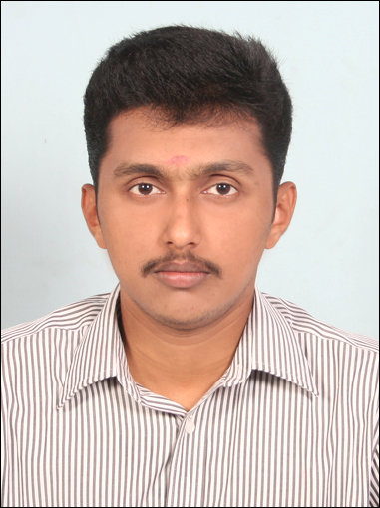
RESUME

Mr.Sreejith M Nair
Veliyath (H)
Kadappattor (P.O) Phone (Res): 04822-201050
Pala- 686574 Mobile : (0)9961676272
Kerala, India Email:sreejithmnair55@gmail.com

CAREER OBJECTIVE:

Securing a challenging position in a leading organization and to be a part of a team where I can utilize my skills and abilities to the best.

JOB EXPERIENCE:

- Company :Axis Bank Ltd
Designation : Assistant Manager - Sales
Duration : From July 2011 to till-date

Job Responsibilities:

- Building and maintaining healthy relations with the banking channel, ensuring maximum business and customer satisfaction by achieving delivery & quality norms.
- Interacting with the customers to gather their feedback regarding the products’ utilities.
- Rolling out work site campaigns for effective lead generation.

Personal Skills:

- Good Team Player
- Good Communication skill

ACHEIVEMENTS:

- Confirmed in Bank's Services within Three Months.
- Qualified in “ HIGH VOLTAGE CAMPAIGN “ ( Banks contest for find the
HIGH VOLTAGE HEROES in Kerala Circle in 2012 )
- Got promoted as Officer sales in 2012
- Got promoted as Assistant Manager- sales in 2014

ACADEMIC RECORDS:

Examination  Passed | Year of Passing | Institution | Board/  University | Marks Obtained
MBA  ( Finance, International Business ) | 2010 | Marthoma College of Management & Technology, Perumbavoor | M G University | 62%
B.COM  (Computer Application) | 2007 | ST.George College, Aruvithura | M G University | 62%
HSE | 2004 | Govt. H.S.S, Pala | HSE | 59%
SSLC | 2002 | ST.Thomas H.S.S Pala | Kerala State Board | 56%

Projects Undertaken

- Interbank Comparative Study of Educational Loans & Customer Preference with special reference to South Indian Bank, Pala branch

Period of Study: Two months

Objective : To understand the interbank comparison and customer perception of educational loan market in Pala town with special reference to SIB..

COMPUTER KNOWLEDGE:

- MS Office
- Comfortable in the internet environment

PERSONAL PROFILE:

Name : Sreejith M Nair
Age and DOB : 27, 17-03-1987
Gender : Male
Martial status : Married
Nationality : Indian
Father’s Name : Manoharan M B
Language known : English,Malayalam
Hobbies : Listening to music, playing cricket & football.
Passport Number : J2501633

References

- Dr. Rajan Varughese
Director/Principal
Marthoma College Of Management And Technology, Perumbavoor.
    0484-2592677

- Mr.Sreekumar
Branch Manager
Axis Bank Ltd .
Mob: 9447041096
  

DECLARATION

I hereby declare that the above statements are true and correct to the best of my knowledge and belief.

Place: Pala
Date: 11/06/2014 Sreejith M Nair

